CHEN/SENG 460/660
HW 2
Due Date: 03/03/2021 (11:59 PM)

- Consider the heart disease medical example. Let the prior probability of a heart disease, P(H) = 10⁻³. Let E = a positive test result, which is 98.6% reliable for those who have the disease. Also, the test is 97.7% reliability for those who do not have the disease.
  - State the expression and calculate the prior predictive probability of the observed event of a positive test, P(E).
  - State the Bayes model expression in terms of H, E and calculate the posterior
probability of disease given a positive test, P(H|E)
  - Use the AgenaRisk software or the GeNIE modeler to set up the Bayes expression in a 2-node (Boolean) Bayesian network with H (disease) and E (Test positive) as the nodes and a directed arc or link from H to E. Enter the NPT (node probability table) data for H and E. Run the calculation to obtain the marginal probabilities for H and E. Include a screen capture of your BN calculation shown in a graphical format.
  - Enter the observation “True” for E (this step is called ‘instantiation for E’), and recalculate the BN to obtain the posterior values of the H distribution of two values. Compare the probability of disease, H = “True”, with the probability of disease value calculated from the Bayes expression in d). State whether these two values agree numerically. Include a screen capture of your updated BN calculation.

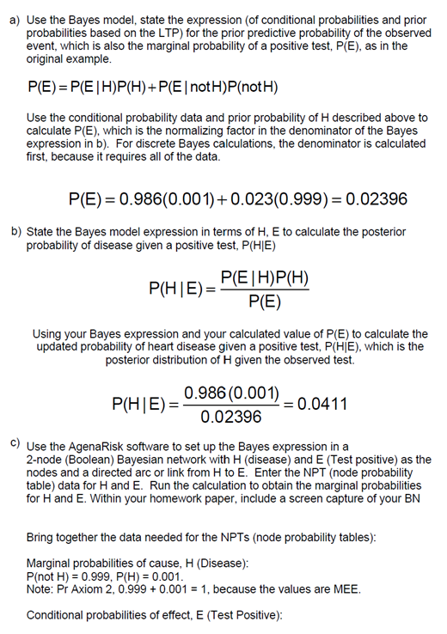
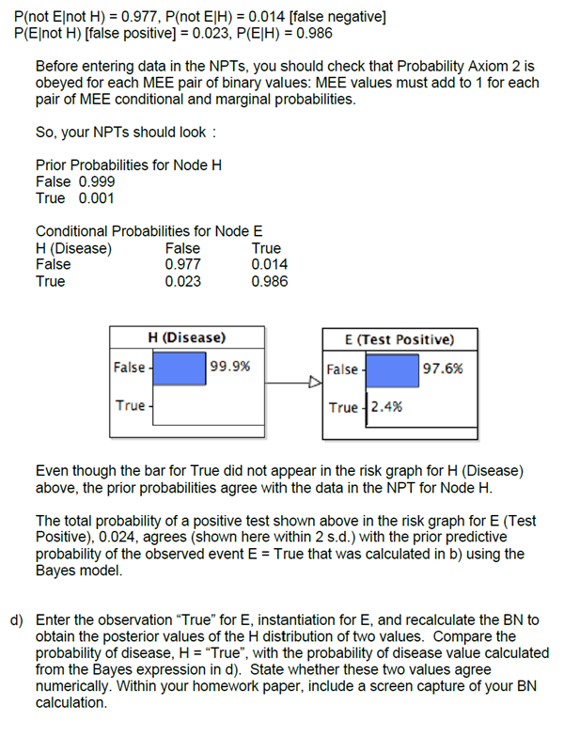

- A new structure will be proof tested. It is assumed that the maximum proof load is specified at sufficiently high level so the calculated probability of the structure surviving the maximum proof load test is 0.9. Based on expert opinion, this 0.9 value is considered to be 70% reliable, but there is a 25% chance that the true probability of surviving the test is 0.5, and there is a 5% chance that the survival probability is only 0.1.
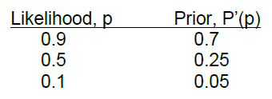

Let p = probability that the structure survives a proof test, so the 3 ‘p’ are values of the discrete likelihood function in the Bayes model, which is the probability of observing the results of a survived proof load test. Use the 0.7, 0.25, 0.05 probability values that the structure would pass the load test based on expert opinion for the prior probability of p (prior to doing the test), P’(p).

- Working as a sports analyst, you are modeling the free throw successes of Lebron James. You are asked to predict the probability that Lebron will make four free throws in serial succession during an important game that takes place in the opposite team’s venue. You express the probability of success in the first free throw as P(T1), success in the second free throw as P(T2), and so on.
Based on your data of Lebron’s previous free throws, you estimate that the median probability (0.5 below and 0.5 above) of a single free throw P(T1) by Lebron under a wide range of expected conditions is 0.75. Also, you estimate that the probability of success in free throw 2 given he made the free throw 1 is P(T2|T1) = 0.8. Also, you estimate that the probability of free throw 3 given he made free throw 2 (with kudos) is P(T3|T2) = 0.9. But because of the extreme conditions at the important game in the opposite team’s site, you estimate that his probability of making free throw 4 given he was successful in free throw 3 is 0.7.

  - Applying the chain rule to a system of four variables, T4, T3, T2, T1, expand the joint distribution function for the system of four variables, P(T4,T3,T2,T1). [For convenience in the following problems, begin with variable T4, and continue with T3, then T2, and finally with T1, so the first conditional probability is P(4|1,2,3)].
P(T1,T2,T3,T4)=P(T4|T3,T2,T1)(T3|T2,T1)P(T2|T1)P(T1)
  - Assuming the Markov Rule for which the probability of the variable is considered dependent only on the previous variable, simplify the expanded expression you found in a. Explain your answer.
P(T1,T2,T3,T4)=P(T4|T3)(T3|T2)P(T2|T1)P(T1).
Because of the Markov Rule, variable T4 is considered dependent on the previous variable T3 but independent of variables T2 and T1. Likewise, Variable T3 is considered dependent only on T2 but independent of variable t1. Since each of throws are only dependent on the previous throw, any throw before the last are not considered.
  - Using the expression and the data, calculate Lebron’s probability of success of four free throws in succession.

P(T1, T2,T3,T4)=P(T4|T3)(T3|T2)P(T2|T1)P(T1)= 0.7(0.9)(0.8)(0.75)=0.38

  - Also, calculate the mean value and variance, and standard deviation of the probabilities where each probability value is equally weighted.

  - Further simplify the expression you obtained in b. to predict the probability of Lebron’s making 4 free throws in series if each free throw is considered independent of all of the other free throw attempts. Calculate the probability of 4 successes if all free throws are independent of each other (Use Lebron’s median Pr value of success = 0.75).

P(T1, T2,T3,T4) = P(T1)⁴= (0.75)⁴=0.32

  - Compare the results obtained in c. and e. and comment on which one you think is more realistic.

Using estimated conditional probabilities is far more realistic than assuming independence of conditions by using data or estimates for free throws under the influences of prevailing conditions, so the analysis including this information, even if resulting in rough estimates given the conditions, can yield more realistic analyses and more accurate predictions than assuming independence of the model variables.

  - Show that the answer you obtained in e. can also be obtained if a Binomial expression was used to calculate the probability of Lebron making the 4 free throws in succession.

P(T1,T1,T1,T1)= $\left(\begin{matrix}4 \\ 4\end{matrix}\right){0.75}^{4}{(1-0.75)}^{4-4}=0.32$

PLEASE NOTE THE FOLLOWING REQUIREMENT:

Each week a different member of the team will upload the homework on Canvas. This member will be the ‘Team Leader’ for that week. Team Leaders MUST fill up the table below, before submitting the homework.

Name of Team Leader for this HW:
Name of Team Members | Problem number solved by member in this homework | Percentage contribution of team member to the overall homework

